ID | 10
Summery | Website layout broken on small screen when viewed on a mobile device
Severity | Critical
Priority | High
Type | Visual
Assigned to | DEV
System/Environment | OS Windows 10x64 Home; Opera: 84.0.4316.31
Precondition | Use https://app.lambdatest.com
Steps to reproduce | - Open the main page http://shop.ck.ua  - Enable emulation on Android, Google Pixel XL3, browser Opera; 1440 x 2960 px 6,3’’  - 3) Pay attention to the layout
Expected result | The site changed the template from desktop to mobile version when the browser window was reduced in size
Actual result | Website layout broken on small screen when viewed on a mobile device
Attachment | 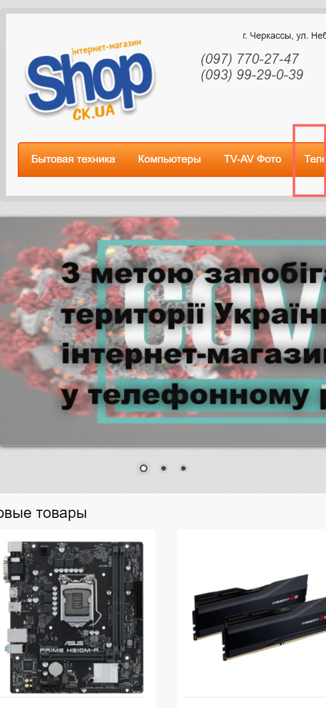

ID | 14
Summery | The price entry field accepts letters and displays an error when pressing the OK button
Severity | Minor
Priority | Low
Type | Functional
Assigned to | DEV
System/Environment | OS Windows 10x64 Home; Opera: 84.0.4316.31
Precondition | Open the site shop.ck.ua
Steps to reproduce | - Hover over the "Computers" button  - Click on the link "Notebooks"  - In filters by price, set the min price to "недорого"  - In filters by price, set the max price to "дорого"  - 5) Click on "OK" button
Expected result | Number fields does not accept letters
Actual result | The price entry field accepts letters and displays an error when pressing the OK button
Attachment | 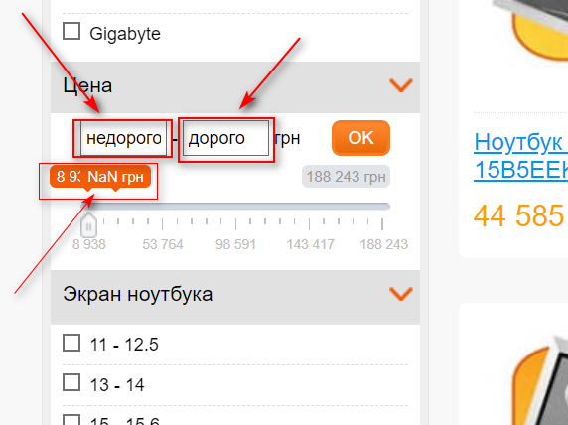

ID | 13
Summery | Feedback form saves callback requests with invalid phone number
Severity | Major
Priority | Middle
Type | Functional
Assigned to | DEV
System/Environment | OS Windows 10x64 Home; Opera: 84.0.4316.31
Precondition | Open the site shop.ck.ua
Steps to reproduce | - Click the link "Заказ звонка"  - Switch the radio button to "Я хочу сделать заказ"  - Fill the form with Name: 1  - Phone number: 000  - Confirm captcha "Я не робот"  - 6) Click the button "Жду звонка"
Expected result | An invalid number message is displayed
Actual result | Contact form saved callback request with invalid phone number
Attachment | 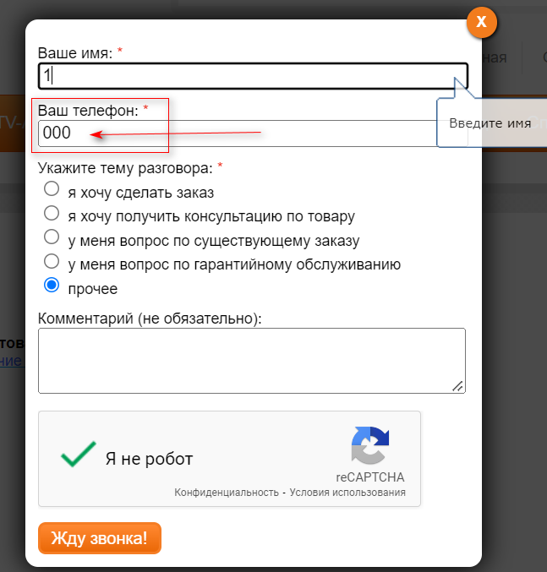  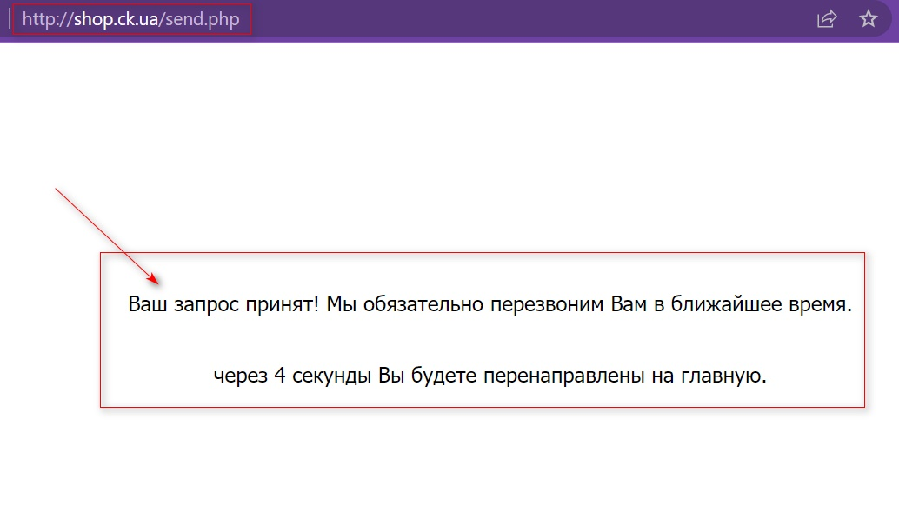

ID | 12
Summery | Horizontal scroll appears after entering a query longer than 90 characters in the search bar
Severity | Major
Priority | Low
Type | Functional
Assigned to | DEV
System/Environment | OS Windows 10x64 Home; Opera: 84.0.4316.31
Precondition | Open the site shop.ck.ua
Steps to reproduce | - In the search bar, enter a query for 90 characters: 123456789123456789123456789123456789123456789123456789123456789123  456789123456789123456789  - Press "Enter" key  - Pay attention to the search result
Expected result | The search result is displayed and the layout of the site does not break
Actual result | Horizontal scroll appears after entering a query longer than 90 characters in the search bar
Attachment | 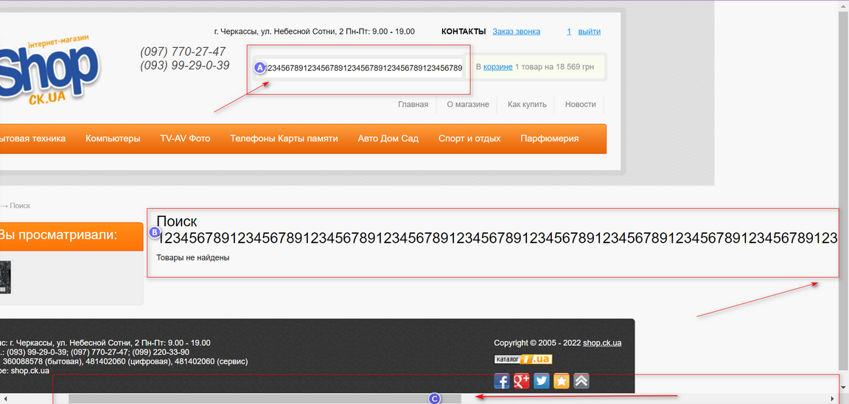

ID | 4
Summery | Successful registration with a one-digit password
Severity | Critical
Priority | High
Type | Security
Assigned to | DEV
System/Environment | OS Windows 10x64 Home; Opera: 84.0.4316.31
Precondition | Open the site http://shop.ck.ua/
Steps to reproduce | - On the main page click "Регистрация"  - Enter name: Ruslan  - Enter e-mail: gra.dp.kr@gmail.com  - Enter password: 1  - Check the box "I'm not a robot"  - Click the "Зарегистрироваться" button.
Expected result | Fail registration: Minimum password length message requiring is displayed.
Actual result | Successful registration with a one-digit password
Attachment | 